‘Investigating Australian Climate Change’

Studio Project: Milestone - Working Application

Working Application Report (20%)

|  |
| --- |
| Sub-Task A by |
| *<Sub-Task A Suleynmon Azadzoi*  *<Sub-Task A s4176672* |
| *URL for your Github Repository* |

Note: To avoid Academic Integrity issues, student must only complete their chosen sub-tasks.

Speak to your instructor when in doubt.

Submitted for Assessment Task 4:   
Studio Project (Milestone – Working Application)   
COSC3106 Python Programming Studio – S1Flex 2025

# 1. Met User’s Needs

## 1.1 User Groups Summary (half page)

## The completion of this milestone project was done individually/solo. This project aims to develop a functional web application powered by data that tackles a social issue by enhancing everyday users' access to climate information. My application specifically targets the visualisation of both historical and recent rainfall trends across Australia to assist users in making weather-based decisions.  The project collects information from the Australian Government Bureau of Meteorology and incorporates it into a platform that is both interactive and easy to use. The website enables users to access rainfall data sorted by location and year while presenting interactive charts that adjust according to user inputs. Developers constructed the application with web technologies including HTML, CSS, JavaScript while utilizing a SQLite database to manage climate data. The platform enables users to examine data through visual exploration tools and a search function that filters outcomes according to their chosen parameters.  This application primarily targets local residents alongside council planning staff and people interested in climate change effects and water resource management. The app's usability-focused design presents an uncomplicated interface alongside filtering options and graph visualisations to accommodate both tech-savvy users and those with less experience.  As a solo developer, I managed every design and implementation aspect including front-end layout, database integration, and usability considerations. My work included creating user personas and scenarios which served as development guides. Balancing solo development with testing presented difficulties, yet this milestone shows a functioning application that fulfills the studio project's design objectives and data requirements.

## 1.2 Sub Task A

### 1.2.1 (Persona 1 + half page of justification)

Persona 1: Michael (University Student)   
At 20 years of age Michael pursues his civil engineering studies full-time at RMIT University. His interest lies deeply in examining the impact of climate change on urban infrastructure and road design. Managing both university studies and a part-time job drives his preference for apps that deliver environmental data through visually intuitive interfaces with rapid access. He habitually reviews climate data for both his academic assignments and future engineering projects. His technical abilities remain average while he operates both desktop and mobile platforms.   
  
The application effectively addresses Michael's requirements.   
Michael benefits from our app which delivers straightforward access to precise, real-time climate information for Australia. Dynamic graphs combined with regional and weather type filters (including rainfall and temperature trends) and mobile-friendly design enable Michael to swiftly gather insights for reports or classroom discussions. The app’s responsive layout combined with its search function and data download capability makes it an effective tool for students with limited time.

### 1.2.2 (Persona 2 + half page of justification)

Persona 2: Aisha (Educator in Secondary School Geography)   
Aisha teaches geography to high school students while residing in Melbourne at the age of 34. She instructs students from Year 9 to Year 12 while constantly seeking educational tools to illustrate environmental and climatic variations throughout Australia. Despite her limited tech skills, she demands interfaces with straightforward navigation along with sizable buttons and engaging visuals for her students during lessons.   
  
Our application effectively addresses Aisha's requirements:   
Aisha accesses region-specific weather visualizations through the app for her PowerPoint presentations. By screen sharing or downloading she manages to present climate graphs in class without difficulty. Large, labeled buttons combined with a straightforward menu setup work to minimize technological complexity. By using filters, she customizes graphs to display specific cities or weather patterns for curriculum-aligned demonstrations.

## 2. Context Scenarios + Key path scenario + storyboard

## 2.1 Sub Task A (Context Scenario + Keypath Scenario + Storyboard)

Michael engages in developing a presentation that examines the impact of climate change on rainfall distribution across Australian urban areas. Brisbane became his team's designated area where they needed to present historical rainfall records. The climate app interface sees his input as he navigates to Brisbane and applies the 10-year rainfall filter. Through intricate steps, he exports the interactive graph from the app and inserts it into his presentation slides. The task reaches completion at an accelerated pace because of the structured layout combined with responsive filtering mechanisms.

Objective: Michael seeks to produce and export a Brisbane rainfall graph covering the years 2014 through 2024.   
Steps:   
1. Michael initiates the climate data web app on his laptop.   
  
2. He navigates to the homepage where he interacts with the “City” dropdown menu to choose “Brisbane.”    
  
3. From the weather type menu, he picks “Rainfall”.   
  
4. Through the intricate mechanisms of slider adjustments or input field entries, he establishes the temporal boundaries spanning from 2014 to 2024.   
  
5. The application constructs a monthly rainfall graph for the specified period.   
  
6. The chart transforms into an image file when Michael activates the “Export” button.   
  
7. The student places his work into PowerPoint before proceeding with his task.

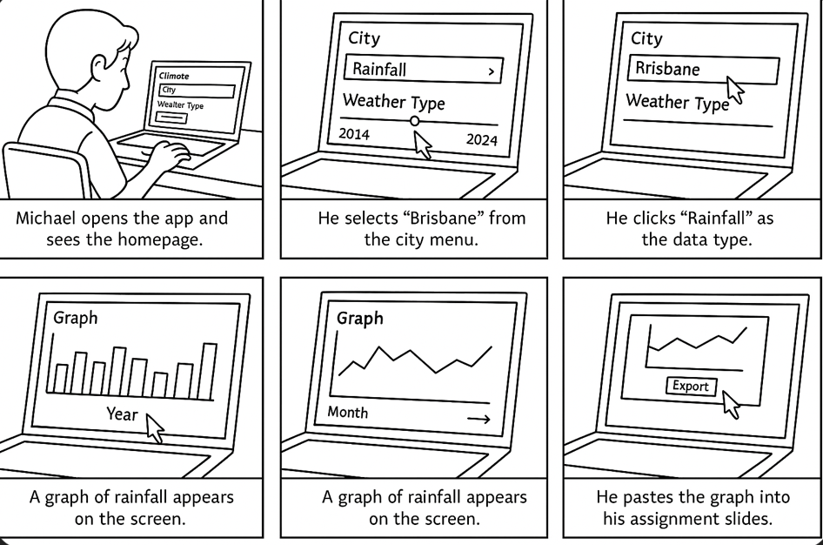

## 3. Wireframes

## 3.1 Sub Task A (Original Wireframe + Improved Wireframe)

Initial Design Concepts (Low-Fidelity Wireframes)   
The initial design concepts for the homepage along with climate trends filter and data results page emerge from these wireframes. These entities emerged to delineate user pathways alongside foundational frameworks.

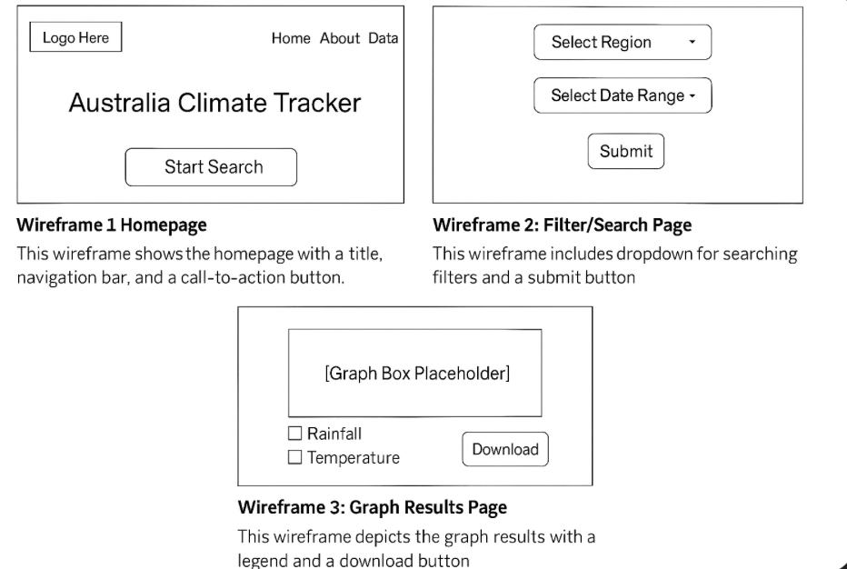

Enhanced Wire Framework (Advanced Structural Appearance)   
This refined version emerges from user needs and usability principles to present enhanced alignment alongside a more defined hierarchy and uniform interactive element placement.

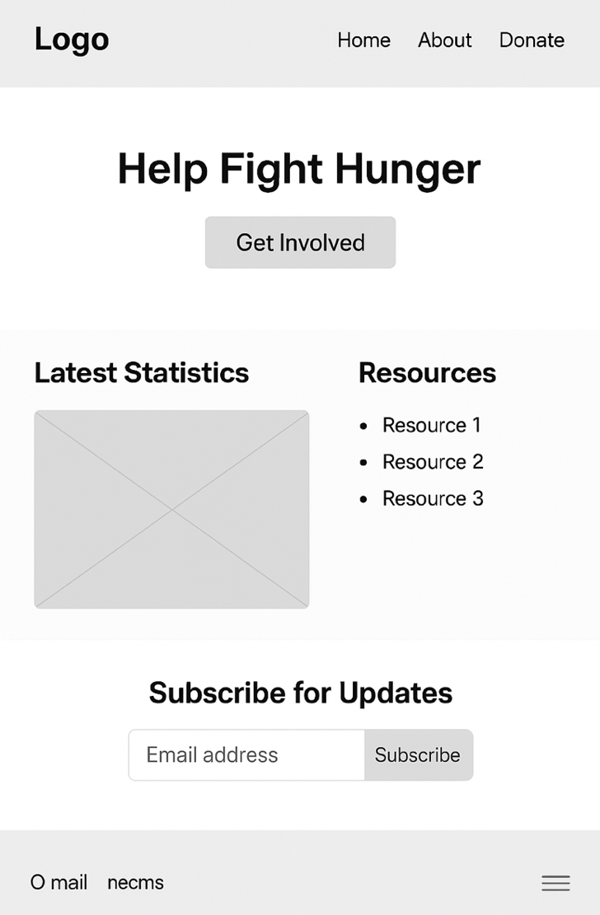

## 4. Nielsen Heuristics

## 4.1 Sub Task A (half page limit)

The creation of this climate data web application involved the implementation of essential usability heuristics and design patterns to enhance user experience while ensuring operational functionality and making the interface accessible for both novice and experienced users.

3 strong choices tailored explanation:

1.The System Status Visibility   
  
During data retrieval from the database, the application displays a loading icon to keep users aware that their requests are under processing. The system's correct operation becomes evident through weather trend analysis and graph filtering activities which install user confidence.

2. Match Between System and Real World   
  
The website presents straightforward phrases such as “Temperature Trends” and “Rainfall by Region” instead of using specialized terminology. The interface becomes more accessible to educators and learners without technical skills through these modifications.

3. Consistency and Standards   
  
All pages exhibit identical layout structures and navigational elements. The menu bar and footer incorporate conventional icons (such as home, search, download) which most users recognize thereby decreasing the learning curve while enhancing operational efficiency.

# 5. Design Patterns

## 5.1 Sub Task A (half page limit)

The application platform utilizes established design patterns to maintain user-friendliness while delivering consistent performance and operational efficiency across all components. The implementation includes two fundamental patterns:   
  
1. Navigation Bar (Page Layout Pattern)   
The navigation bar stays fixed at the top of each page where it remains constantly visible. The interface presents fundamental components like Home, Search, and Download buttons which facilitate user navigation across the website. This system prevents users from losing their way while maintaining uniform availability of essential functions no matter their app location.   
  
2. Search and Filter Panel (Search Pattern)   
The application employs a sidebar filter featuring dropdown menus and sliders to enable users to refine data according to city, weather type (rainfall/temperature), and year. This matches expected user search patterns which make exploration easier while helping users find relevant climate data quickly.

# A screenshot of a computer AI-generated content may be incorrect.6. ERD & Relational Schema

Relation Schema:

CREATE TABLE City (

city_id INTEGER PRIMARY KEY,

city_name TEXT NOT NULL

);

CREATE TABLE WeatherData (

data_id INTEGER PRIMARY KEY,

city_id INTEGER NOT NULL,

date TEXT NOT NULL,

rainfall_mm REAL,

tempreture_c REAL,

FOREIGN KEY (city_id) REFERENCES City(city_id)

);

SQL Query:

SELECT

City."city_name",

WeatherData."date",

WeatherData."rainfall_mm",

WeatherData."tempreture_c"

FROM

WeatherData

JOIN

City ON WeatherData."city_id" = City."city_id";

The SQL query showcases data extraction from WeatherData and City tables through a JOIN operation on the common city_id key. Relational integrity is maintained by the FOREIGN KEY which links every weather entry to an existing city record. The JOIN operation consolidates data fields including city_name, date, rainfall_mm, and tempreture_c into a single result set.

The screenshot above displays a successfully executed SQL JOIN query which merges WeatherData table records with City table entries through the foreign key city_id. The application verifies relational integrity and data retrieval success which supports its user-focused features.

# 7. Reference List

Bureau of Meteorology, “Climate Data Online,” Australian Government, 2024. [Online]. Available: <http://www.bom.gov.au/climate/data/>

[2] SQLite Consortium, “SQLite Documentation,” 2024. [Online]. Available:

<https://www.sqlite.org/docs.html>

[3] J. Nielsen's work "10 Usability Heuristics for User Interface Design" appeared through Nielsen Norman Group in 2020. [Online]. Available:

<https://www.nngroup.com/articles/ten-usability-heuristics/>

[4] Mozilla Foundation presents “HTML reference” within MDN Web Docs, 2024. [Online]. Available: <https://developer.mozilla.org/en-US/docs/Web/HTML>

[5]W3Schools,“CSS Reference,” 2024. [Online]. Available: <https://www.w3schools.com/cssref/>